Name of Acid: acetic acid (CH3COOH)

Name of Base: sodium hydroxide (NaOH)

Name of Indicator: phenolphthalein (C20H14O4)

Molar Concentration of Acid: CA = 0.2074 M

Volume of Acid: VA = 25.00 mL

Volume of Base: VB = 0.02 mL

$C_{B}=\frac{0.025 *{ C}_{A}- 10^{-7} * (0.025 - V_{B})}{V_{B}}$

$C_{B}=\frac{0.025 *0.2074 M - 10^{-7} * (0.025 - 0.02 mL)}{0.02 mL}=0.259249975 ≈0.259 M$

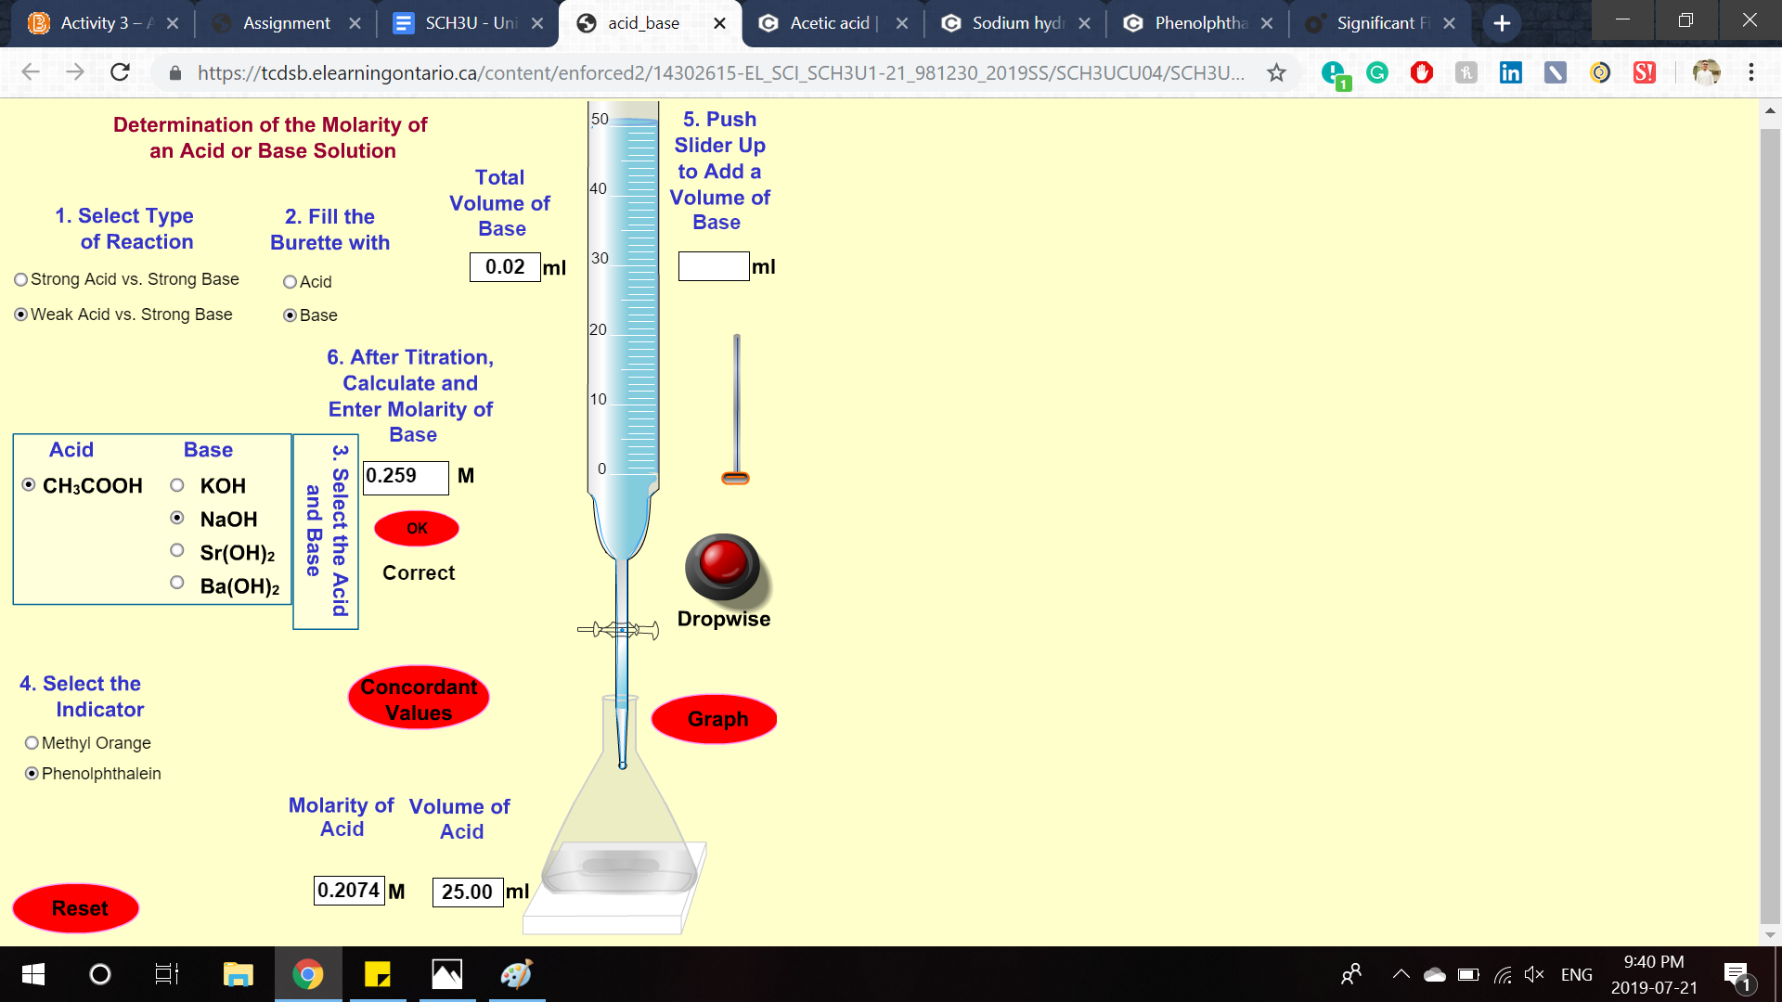

References

Acetic acid. (n.d.). Retrieved from https://pubchem.ncbi.nlm.nih.gov/compound/Acetic-acid

Phenolphthalein. (n.d.). Retrieved from https://pubchem.ncbi.nlm.nih.gov/compound/Phenolphthalein

Sodium hydroxide. (n.d.). Retrieved from https://pubchem.ncbi.nlm.nih.gov/compound/Sodium-hydroxide